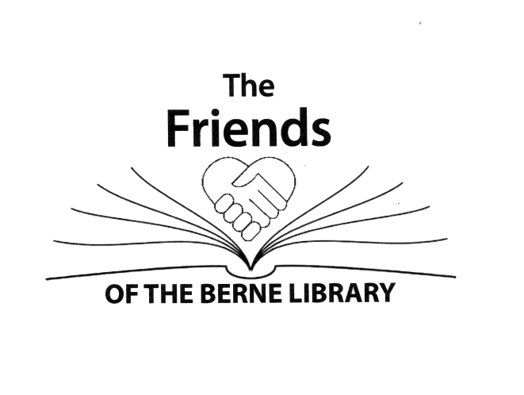

11th Photography Contest

Photographs must be submitted by Saturday, January 31, 2026

Enter a photo that fits one of the following categories:
- All Creatures Great and Small
- Favorite Hilltown Views
- Planes, Trains, Autos, etc
- Shadows and Textures

Enter one 8 x 10 photograph per category with up to four submittals. All photographs must be the personal work of the entrant. There are two divisions for entrants: ages 8 to 18 years of age, Junior Division, and over 18 years of age, Adult Division. There is a $5.00 entry fee per photo for the Adult Division and no entry fee for the Junior Division.
- Drop off your photo at the Berne Library.
- Please give your photo a title.
- The entry form must accompany the photo.
- The entry fee of $5 for entries in the Adult Division should be dropped off at the library. Include the name of the photographer and the image title with the entry fee.
The photos will be judged by guest judges. The guest judges will select a Best of Show winner for the Adult and for the Junior Divisions. The library community can vote for their favorite photo in the Adult and Junior Divisions in the People’s Choice Vote. Gift certificates will be awarded to Best of Show winners and People’s Choice Vote.
No identification of the entrant is allowed on the front of the photo. Photos will be accepted through Saturday, January 31, 2026 during regular library hours at the circulation desk of the Berne Library. NO ENTRIES will be accepted after the deadline.
Winners will be announced mid-February and will be contacted by phone or email.
If you have any questions, email bernelibraryfriends2@gmail.com.
Fill out the entry form on back and submit the form with your photo by January 31, 2026 at the Berne Public Library.

Entry Form: Please print clearly.
Friends of the Berne Library Photography Contest entry form
Name_______________________________________________________________________
Address____________________________________________________________________
______________________________________________________________________________
Telephone_________________________________________________________________
Email_______________________________________________________________________
Circle division: Adult Junior Age if under 18 __________
I understand that neither the Berne Public Library nor the Friends of the Berne Library is responsible for any lost, stolen, or damaged photographs.
Signature___________________________________________________________________

Check the category for your photo:
- All Creatures Great and Small

- Favorite Hilltown Views

- Planes, Trains, Autos, etc

- Shadows and Textures

Image Title____________________________________________________________

