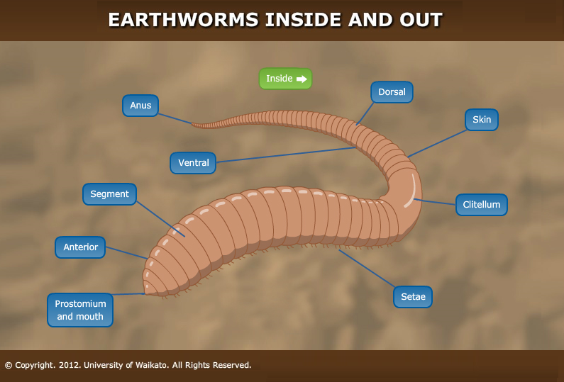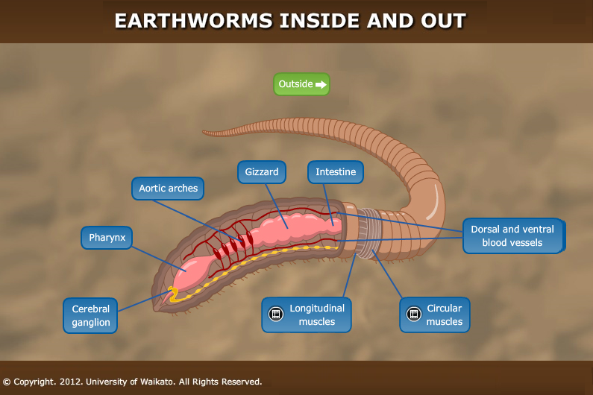

https://www.sciencelearn.org.nz/image_maps/24-inside-of-an-earthworm

Activity ideas from This is a Book to Read with a Worm by Jodi Wheeler-Toppen, illustrated by Margaret McCartney.
You will need: water, paper towels, a flashlight, a bottle of rubbing alcohol, a cotton swab, a sandwich bag, a sheet of paper, a clear plastic bottle, and aluminum foil.
And a worm!
- Shine your flashlight at the worm’s head. What happens?
- Dip your cotton swab into rubbing alcohol and hold it near, not touching, your worm’s head. What happens?
- Look closely at your worm’s head. Can you see its pharynx that the worm uses to grab food?
- Slip your worm into a plastic bag, but don’t seal it closed. Shine the flashlight through the bag. Can you see your worm’s digestive system?
- Let your worm rest on a wet paper towel. Watch your worm move!
- Can you see how your worm uses its setae (thin, stiff bristles on each segment) to move?
- Roll up a sheet of paper into the shape of a megaphone. Set your worm inside the megaphone. Can you hear your worm making noises as it uses it setae to move?
- Ask an adult to cut the top off a clear plastic bottle. Fill the bottle with soil and leaf bits. Cover the bottle with aluminum foil to block out the light. Add a few drops of water if the soil seems too dry. Leave covered overnight. Check the next day to view the tunnels your worm made!
- Don’t keep your worm too long. Release it back into the same place where you found it.

